**CP Club 365Days Challenge**

**Programming language – c++**

**Problem Statement**

<https://www.hackerrank.com/challenges/lonely-integer/problem?isFullScreen=true>

**Your Code**:

// 0x50Day of 0x365Days challenge

// VEDANT BHARAD

// 06-12-2022

#include <bits/stdc++.h>

using namespace std;

string ltrim(const string &);

string rtrim(const string &);

vector<string> split(const string &);

int lonelyinteger(vector<int> a)

{

    int answer = 0;

    for(int loop = 0; loop < a.size(); loop++)

    {

        answer^=a[loop];

    }

    return answer;

}

int main()

{

    ofstream fout(getenv("OUTPUT_PATH"));

    string n_temp;

    getline(cin, n_temp);

    int n = stoi(ltrim(rtrim(n_temp)));

    string a_temp_temp;

    getline(cin, a_temp_temp);

    vector<string> a_temp = split(rtrim(a_temp_temp));

    vector<int> a(n);

    for (int i = 0; i < n; i++) {

        int a_item = stoi(a_temp[i]);

        a[i] = a_item;

    }

    int result = lonelyinteger(a);

    // fout << result << "\n";

    cout << result << "\n";

    fout.close();

    return 0;

}

string ltrim(const string &str) {

    string s(str);

    s.erase(

        s.begin(),

        find_if(s.begin(), s.end(), not1(ptr_fun<int, int>(isspace)))

    );

    return s;

}

string rtrim(const string &str) {

    string s(str);

    s.erase(

        find_if(s.rbegin(), s.rend(), not1(ptr_fun<int, int>(isspace))).base(),

        s.end()

    );

    return s;

}

vector<string> split(const string &str) {

    vector<string> tokens;

    string::size_type start = 0;

    string::size_type end = 0;

    while ((end = str.find(" ", start)) != string::npos) {

        tokens.push_back(str.substr(start, end - start));

        start = end + 1;

    }

    tokens.push_back(str.substr(start));

    return tokens;

}

**Output (Screen Shot)**:

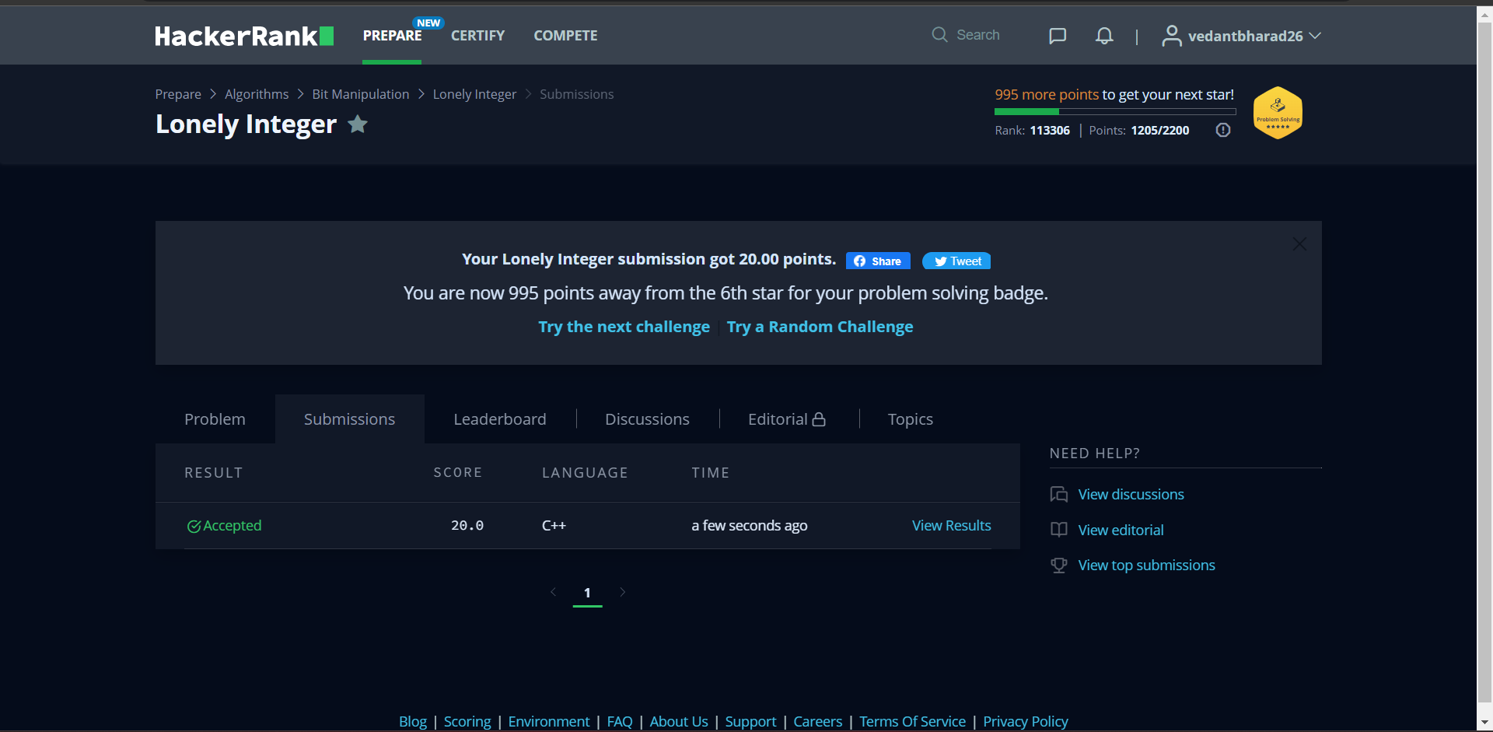

**Understanding about problem:**

* In this task I need to return number which is unique in the given array.
* Here I used xor operation so it will return unique number from array.

Note: If you can't understand the problem, feel free to contact us and we'll help you. Please don't copy and paste from anywhere.

ALL THE BEST

Team CP Club